**WWW - World Wide Web**

**1.1 World Wide web Introduction**

**Web browser**

**-** Visualize pages on web document.

- Contains link, button, video, image

**internet :**

- hardware - global network of machines , and devices that facilitate interaction

**nodes -** computes

**edges -** connection

**www :**

- software - application on top of internet - using hardware infra structure

- also protocol for communication

- composed of document that are linked to each other through web-browser

**nodes** - documents/content/resources

**edges**- links between documents

**Addresses**

URI - uniform Resource Identifier - unique

URL - uniform resource Locator - type of URI. location on www and protocol

*http://www.example.com/home/inde.html?a=12&b=34*

*http :* protocol

*www.example.com :* host name

*example.com :* domain name

*home/inde.html :* file path

*a=12&b=34 :* query parameter

**Protocol:**

Structure of content of communication between devices

**Contents on www**

**static:** Contents does not change, -who, when-html,css

**dynamic:** content changes - user, event -js

request - receive / send - how display - how generate dynamic content

**1.2 HTTP Client Request, Server Response**

**View content on WWW:**

1980's - text web browsers

1095s - mosaic web browser - images and links between pages

**web browser :**

software displays content and let you navigate

component:

Rendering engine -

decides what to display and how to display on web browser.

presentation, ordering, content

html, css

Java script Engine-

dynamic part - create modify

run code

Web browser works -

http protocol -

web browser communicates - request, transfer documents

client -(laptop, mobile, fridge)

server - server /big computer

connected via connections , devices

client initiates - http request

server - listens - decides response and content and sends http response

client again - decides what to do with the content from server response

http:

plain text, human readable protocol on the web

client server model

request + client info

response + server info

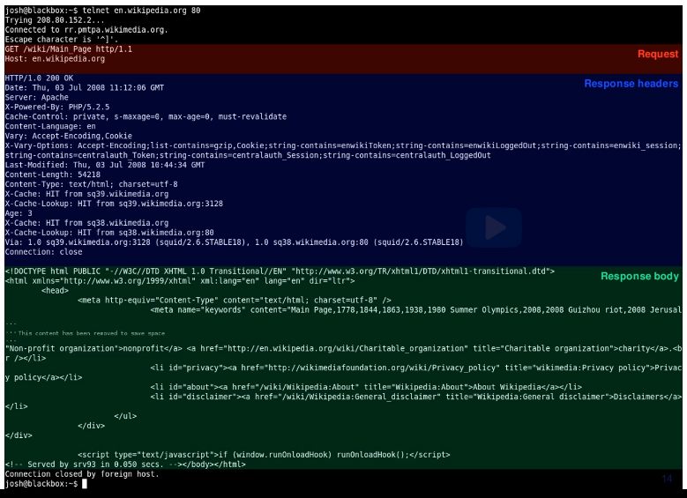

**http request**

verb - Action client hoping to perform

get - requesting resource

head - just header info, not any resource

post -create new content on server

argument - name of the resource requested

protocol - http/1.1

client information + other information

Ex:

Request Verb URI HTTP Version

----- --------------------------- -----------

GET /example/index.html HTTP/1.1 ------------> Request Line

Host: www.edx.org |

User-Agent: Mozilla/4.0 |-----------> Request header

Accept-Language: en-us |

Content-Length: 9 |

-------------> Blank Line Separator

a= 12 & b=34 -------------> Request Message Body

**HTTP Response -**

1st line

Protocol and status code

1XX - Information only

2XX - Success

3XX - Client redirect

4XX - client error

5XX - server error

Most common status codes

200 OK - request succeeded , returning contents requested

404 Not Found - requested resource does not exist

500 Server Error - Error on server side while processing request

2nd line

header information - info about server / info of content

3rd line

blank separator

4th line

response body - content of page requested

Ex:

HTTP Version Status Code

---------- --------

HTTP/1.1 200 OK -----------------------------------> Response Line

Date: Fri, 06 Apr XXXX 09:30:00 GMT |

Server : Apache/1.4 |

Last-Modified: Wed, 04 Apr XXXX |

Connection: close |------------> Response Headers

Content-Type: text/html |

Content-Length: 228 |

--------------> Blank Line Separator

<!DOCTYPE html> <html><Head> --------------> Response Body

**HTML**

**1.3 HTML Basic**

**HTML -**

Structure content / data on WWW

html document - elements -tags - can be nested

plain text - human readable

structure

doesn't decide how to display - web browser decides

**Tags**

<!DOCTYPE html> - version of html

<html> - all contents within

<head>- info of document

<title> title bar

<link> link to other document ex: css -styling

<meta> provide additional information Ex: keyword used by search engine

<script> link to dynamic content Ex: Javascript

<body> - content to be displayed Ex: image, text

**HTTP and HTML -**

browser request for content

client - http request

server - response - content - plain text -html

browser - how to display

Browser - View source Code

html page - right click - view source -html source

**1.4 Important HTML Tags**

<p> : separate paragraph

<h1><h6> : headings

<b> : bold <strong>

<i> : italic <em>

<hr> : horizontal line

<br> : break line

<div> : division. content goes together. useful in styling

<span> : text part. smaller content than div. styling

<!-- comments -->

&nsbp; : single white space

&lt; &gt; : less than / greater than

&amp; : & symbol

&copy; &reg; : copy and registration symbol

**1.5 HTML Attributes**

HTML Attributes -

additional information to tag

name value pair

Ex: <p name="value">

title : title of element. see title when hover over element

<h1 title= "heading">

style: how the content will appear. multiple sub key value pair

<h1 style =" color:red; text-transform:capitalize">

background-color: red, #012345

font-family: verdana, courier

font-size: 12px, 4in, 200%

text-align : center, left, right

id : (#) unique identifier to html element within html tag within html page can be used to formatting

class : (.) subgroup of elements

html - style tag

**1.6 CSS - Style - CSS**

- http response : html

- html looks for css

- inline / same html file / separate file

- separate file - client makes another request for css -http response

- html apply css

inline css:

<h1 style="color:red:>heading1</h1>

advantage : easy to use when want something just once

disadvantage: mixing content html and css

same html :

<style>

h1 { -----> CSS selector

color: red; -----> property: value pair

}

</style>

Advantage: separate content in head, easy to use

Disadvantage : head might get big, html specific

External CSS:

separate file - link within the head

.html

<head>

<link rel="stylesheet", type="text/css", href = "movie-styles.css" />

</head>

.css

h1 {

color:red

}

Advantage : separate content and html , can use css file for multiple pages

disadvantage : need to manage files

css selectors:

external selector :

h1 { color:red; }

all <h1>

class selector :

.address { ... }

<div class="address"> ... </div>

id selector:

#section1 { ... }

<p id="section1"> ... </p>

1.7 Other HTML tags

Lists:

ordered : <ol> <li>

unordered : <ul><li>

Style :

<ul style="list-style-type:circle"> <li></li> </ul>

<ol type="A> <li> </li> </ol>

Nested List : <ul> <li> </li>

<li> </li>

<ol>

<li> </li>

<li> </li>

</ol>

<li> </li>

</ul>

Forms:

<input type="value">

text

email

password

date

range : slider - min, max

radio : value

checkbox : value

color

file

submit

reset

button

hidden : hidden input file

image : image as submit button

month : Month and year control

time : time control

number

tel : phone number

url

**1.8 Links, tables and images in HTML**

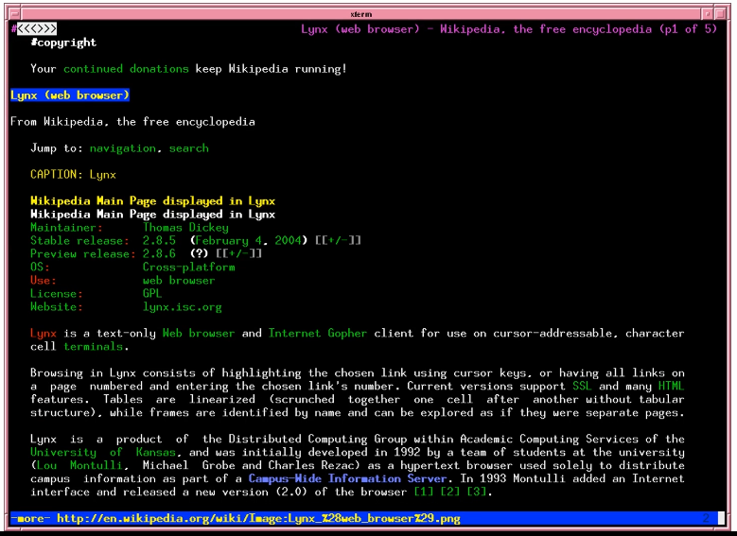

<img> :

not in the html page

link to image

attribute : alt, src, height, width, title

src - absolute path, relative path

links:

surf one page to another page

<a>

href : location (absolute, relative)

target : link should be open in new window/tag

text : clickable link

</a>

bookmarks: link within webpage

id - attribute

< ahref=#health>

tables:

<table> border=1

<tr> <th>

<tr> <td>

border

padding

text-align

border-spacing

rowspan : span rows

colspan

1.9 Using Bootstrap

IBM

users - different devices

responsive web designing (RWD)- smaller device - fills space on webpage accordingly

different CSS for different devices

bootstrap - automatic web response

- grid system

bootstrap

html - head - link tag, js lib, meta tag,

body - apply bootstrap - container class

grid system - content - organized in rows -

horizontal group of 1 to 12 columns

JavaScript

**2.1 Developing in JavaScript**

HTML : structure of contents

CSS : specify appearance

JS: dynamic content of webpage

3 ways to develop JavaScript:

1. <script> : embed in html page

<link> : link to external js file

2. REPL : Read-Evaluate-Print-Loop

Chrome console - write js and see output

3. JS file : Js file. execute in standalone environment - Node.js

JS interact with HTML

framework for client side JS

framework for server side JS

Course :

JS 1.7, Chrome 58.0, Mac OSX 10.11.5

**2.2 Primitive Data Types**

Variable declaration

var age=22;

var name='Uday';

var isMale=True;

Variable View

document.write(age);

console.log(age);

alert(age);

REPL > age

Changing Variable type:

var id = 33.2;

id = 'secret'

5 primitive types:

Number - float, int

Number('tree' ) : NaN

Number.Max_Value()

arithmetic operations

String

'Uday' "Uday's" , '\n' '\t' '\\'

Strings are immutable

.concat() , toUpperCase(), toLowerCase()

name.length

'Hello, '+name;

Boolean

Truthy : true, 'cow', 'false' 5 ..

Falsy : false, null, undefined, 0, NaN, '' ..

Null

no value, empty

Undefined - not seen before

no value assigned yet, just initialization

**2.3 JavaScript array and object**

**Array**

collections of data types

array of same value, different value

view element of array

var myArray = ['cars' , 12, false];

var age = myArray[1]

myArray.length

myArray[4] : undefined

myArray[-9] : undefined

Add element to array

myArray[4] = 'panda'

myArray [-5] = 'elephant'

console.log(myArray)

//(5) ['cars' , 12, false, undefined X 1, "panda", -5: " elephant "]

var myArray = ['car' , 'bike'];

myArray.push('scooter') ; ://car, bike, scooter

myArray.unshift('scooter'); ://train, car, bike, scooter

Vehicle =myArray.pop() ://train, car, bike

Vehicle =myArray.shift() : // car, bike

**Object:**

collections of var, values

key-value pair within {}

variables are called property

accessed by .property

var person = {

name: 'John Doe',

age: 25,

isMale: true,

personality: ['patient', 'loyal', 'happy'],

company: [name: 'edX', id:2984]

}

console.log(person.age); //25

console.log(person['company'].id //2984

Modifying object:

person.isMarried: True;

**2.4 JavaScript Control Structure**

**Conditional statement**

car a =

var b =

var max;

if(a>b){

max = a;

}

else{

max=b;

}

console.log(max);

**comparison operator**

== 1='1' //true

=== equal to and same type

!=

!== not equal to or different type

>

>=

<

<=

**Logical Operator**

||

&&

!

**Comparing Number to String**

compare operation, JavaScript converts String to number

5 < '20' //true

'zebra'>'giraffe // true //alphabetical

**compare objects**

var cooper = {age:11}

var flanders = {age:11}

if(cooper == flanders) //false

if(cooper ===flanders) //false

alias then true

var myDog ==cooper;

if(myDog==cooper) //true

**Loops**

var n =

var fact = 1;

for (var i; i <= n ;i++) {

fact *= i ;

}

var i=1;

while(i<=n) {

fact *= i;

i++;

}

var i=1;

do{

fact *=i;

i++;

}

while(i <=n);

**2.5 JavaScript Functions**

function fact(n){

var product =1;

for (var i=1; i<=n; i++) {

product *= i;

}

return product;

}

var x =

var f = fact(x);

console.log(f);

//apply array to function

var nums=[4,8,12,2];

function print_func(n) {

console.log(n);

}

nums.forEach(print_func);

function isEven(n) {

return n%2 == 0;

}

nums.every(isEven); //true

nums.some(isEven);

function square(n){

return n*n;

}

var sq = nums.map(square); // [16, 64, 144, 4]

//returns new array

**Pass by value**

- primitive arguments are **passed by value**

- function cannot change them

function tryToChange(x){

x=4;

};

var y=11;

tryToChange(y);

console.log(y); //still 11

**Passed by reference:**

object arguments are passed by reference.

function changeMe(obj){

obj.age++;

};

var p = {age:30};

ChangeMe(p);

console.log(p.age); //now 31

**Functions are object**

JS functions are objects

functions can have properties

we can refer variable to them

var add = function(a,b) {

return a+b;

};

console.log(add(3,5));

JavaScript functions can also be declared and used in object

var johnDoe = {

name: 'John Doe',

age: '32',

greeting: function() {

return 'Hello! Nice to Meet you!';

}

}

console.log(johnDoe.greeting());

**Object Prototype**

prototype : basic set of properties from which it can inherit

__proto__ property: object which has proto

root prototype property : Object.prototype

object to inherit properties of other objects

**Create Prototype:**

like class definition

this - current object

new - create new object

function Person(name,age) {

this.name = name;

this.age = age;

this.greeting = function(){

return 'Hello! '+this.name;

}

}

var johnDoe = new Person('John Doe', 32);

johnDoe.greeting();

var janeDoe = new Person('Jane Doe', 28);

johnDoe.greeting();

**Extending Prototype:**

function Student(name, age, school){

***this.__proto__ = new Person(name,age);***

this.school = school;

}

var sarahBrown = new Student('Sarah Brown', 17, 'PennX');

sarahBrown.greeting();

sarahBrown instanceof Person; //true

**Prototype properties**

var Person = function(name, age, occupation){

this.name =name;

this.age=age;

this.occupation=occupation;

}

***Person.prototype.planet = 'Earth';***

***Person.prototype.introduction = function() {***

***return 'I am a '+this.occupation;***

***}***

var johnDoe = new Person('John Doe', 32, 'Denstist');

johnDoe.planet; //earth

johnDoe.introduction // I am a Dentist

**2.6 JavaScript Regular Expression**

**JavaScript Strings**

Character sequence

Strings are immutable

Strings are object and has its own functions

var name ='toucan';

name.length; //6

name.charAt(3); //'c' //index-0 based

name[3]; //'c'

var animal = 'cat';

animal[0] = 'r';

console.log(animal); //still 'cat'

animal.toUpperCase(); //CAT

console.log(animal); //'cat'

var msg = ' Hello Everyone ';

msg = msg.trim();

var my = 'cat.concat('mouse'); //catmouse

msg.startsWith('Hello'); //true

msg.startsWith('HELLO'); //false

msg.endsWith(''Everyone'); //true

msg.includes('JavaScript'); //false

index of contained substring

var title = 'the title of my book';

var start = title.search('title'); //4

start = title.search('banana'); //-1

**regEx:**

pattern of characters

string search function

var status = 'I am working VERY hard';

status.search(/VERY/); //13

status.search(/very/); //-1

status.search(/very/i); //13

/script/.test('javascript is so much fun!'); //true

var numbers '5 8 2 5 7 6';

numbers.search(/[012]/); //4 (2)

/[012]/.test(numbers); //true

var password = 'passwprd4real';

password.search(/[a-z]/); //0 //0-char

password.search(/\d/); //8 //4-digit

using Ranges

var code = 'abc123d4e5';

code.search(/[0-9][a-z][0-9]/); //5 //3d4

not in range [^ ] not

var chars = 'abc123B456';

chars.search(/[^0-9a-z/); //6 //B

Quantifiers

optional single occurrence-0 or 1

/[a-z][0-9]?[a-z]/.test('a1b'); //true

/[a-z][0-9]?[a-z]/.test('abc'); //true

/[a-z][0-9]?[a-z]/.test('a123b'); //false

multiple occurrences - 0 or more

/[a-z][0-9]*[a-z]/.test('a123b'); //true

starts with and ends with matches

/^[a-z][0-9]/.test('a1b'); //true //^[ ]--starts with

/^[a-z][0-9]/.test('ab12');

/^[a-z][a-z]$/.test('123abc'); //true //$ -ends with

/^[a-z][a-z]$/.test('123abc456'); //false

exact match /^..$/

/^[a-z][0- 9][a-z]$/.test('a1b') ; //true

/^[a-z][0- 9][a-z]$/.test('a1b2c'); //false

/^[a-z][0- 9a-z]*[a-z]$/.test('a1b2c'); //true

**2.7 intro to the DOM**

DOM

- document object Model

- structured tree representation of a web page

- HTML of every web page is turned into a DOM representation by browser.

- HTML Specifies Structure of content - DOM allows us to access the structure

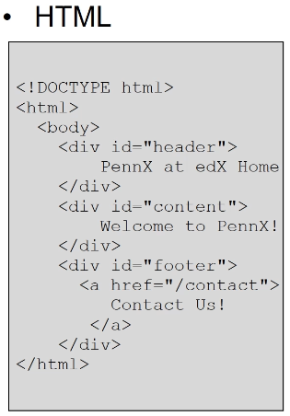

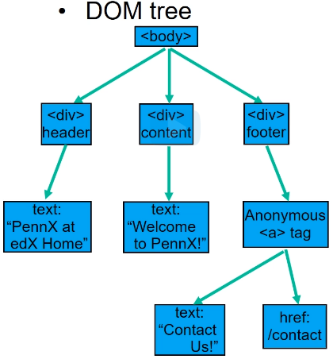

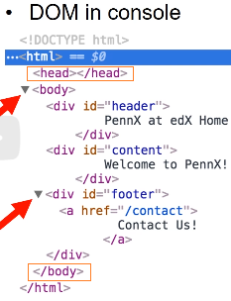

- global root element - document -> html

- elements un DOM tree can be retrieved and manipulated

JS to manipulate HTML

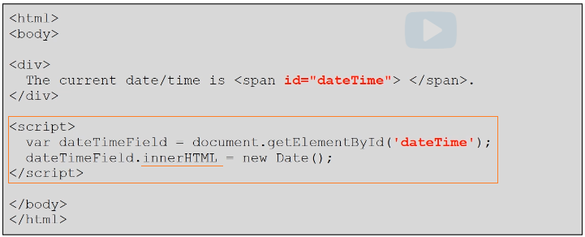

Store data across multiple page request

- global variable - localStorage

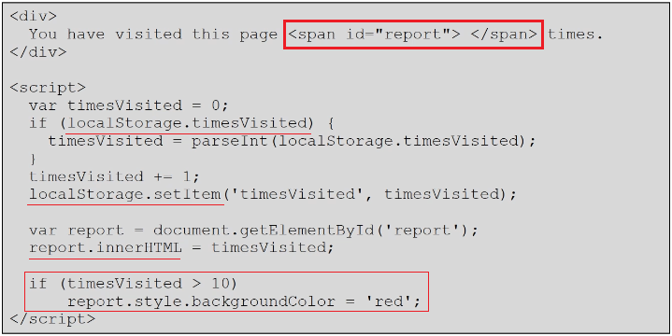

**2.7 Object as JSON**

-javascript object notification

-storing object in local storage

-textual representation of JS

-object can be store as String.

-exchange data between programs

-key-value pair

Storing JSON

- objects in between page request

-JS object converted to JSON

JSON.Stringify(myObject)

-String to JS Object

JSON.parse(jsonString)

All value must be a -

string,

number,

array,

boolean,

null,

another JSON object

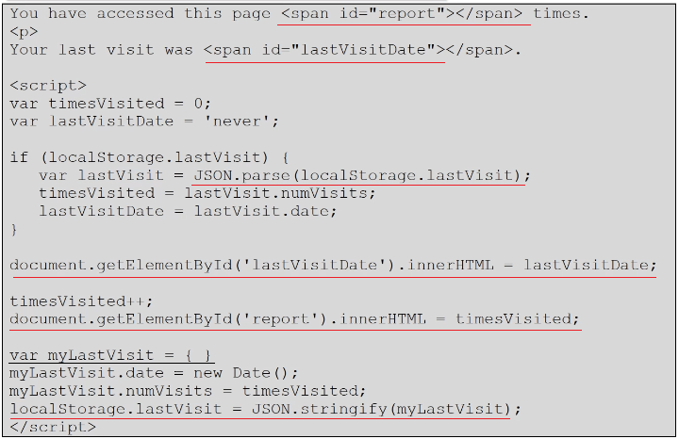

**2.8 DOM Event**

- Event driven programming.

- program behavior based on Event

- call back function

- asynchronous programming

- synchronous prog - wait for user input .keep checking

**2.9 Introduction to jQuery**

- Simplifies JS usage on web apps

- Easy with DOM

- Cross browser support

- Animation and effects

- download jQuery.com

- add downloaded .js file to HTML page

<script src="jQueryFile.js"> </script>

- select DOM using $

$("*") all elements

$(this) current element

$("div") all <div> element

$(".title") class="title"

$("#name") id ="name"

-Manipulation

$(selector).action(args...)

$("#name").html("hello");

$("#name").append(" world!");

$("#name").addClass("greeting");

$("#name").hide();

$("#name").show();

- Add event listener

$(selector).event(callback)

callback

-name of event

-name of function

**2.10 jQuery event handling**

select elements of DOM

Advance Selector:

$(someNodes).find(selector)

$ selectors can be chained

- $("div.book") : -div with class="book"

-$("div, .book"):- all divs and all class="book"

-$("p:hidden"):- element p with property hidden

-$ these selectors are css selectors

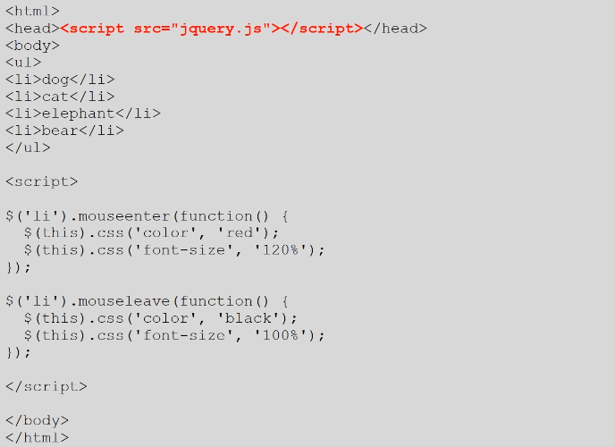

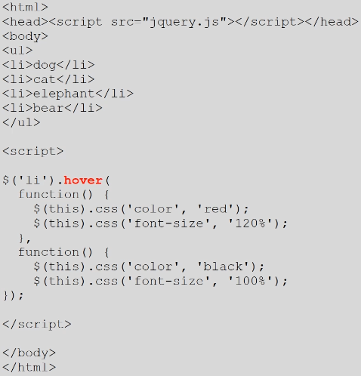

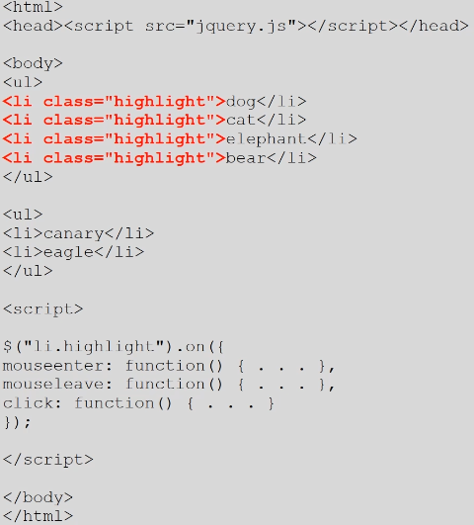

2.11 jQuery Event handling 2

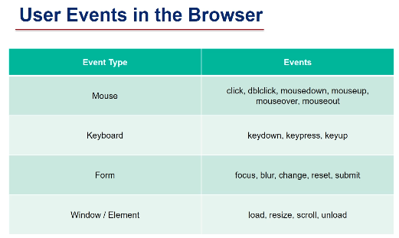

3.1 Introduction to React

- jQuery library to manipulate DOM

React:

- build user interfaces

- webpage is composed of components that have a lifecycle and state change, which affects how they are rendered.

- introduced - virtual DOM which allows add/Remove elements

- Facebook

3 Features

1. Modularity

- organize module that can work together

2. Lifecycle Maintenance

- modifying component based on its state,

- add event listeners

- simplify conditional component render

3. JSX

- embed html into javascript

Components

- core of react

- make nodes inside VirtualDom

- each component include and maintain state that changes with events

- components maintain their state and application can be configured to respond to state of individual component.

Virtual DOM

- structural html elements

- Virtual DOM: selectively renders-re-renders subtree of nodes based on state changes

- Virtual DOM does least amount of DOM Manipulation to update components

Normal DOM - node updated - browser updates all nodes

Virtual DOM - node updated - React figures out which part of DOM need to change, only changes nodes that are affected.

-diff : identify node that is changes

-reconciliation : update nodes that are affected by the change

re-render only node affected by change

Developers steps with React:

1. within HTML - allocate position on page in which desired react component will be rendered eg: div

2. create react component in JS

- establish an initial state

- define any event that could change the component state over lifecycle

- render function for the HTML

3.Drop component into position allocated in Step1

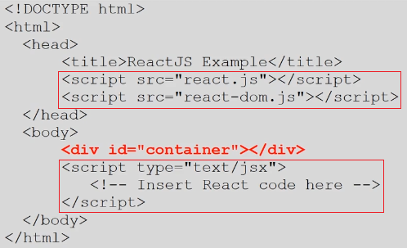

JSX

- JS XML Syntax Transform

- HTML tag within JS

- Converts text(HTML) to React code

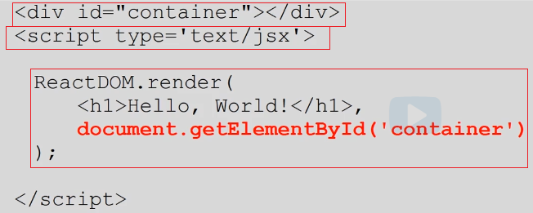

3.2 React Component

- modular reusable code

- drop into html

- generate content dynamically based on state and use events

- js object -based off React.Component prototype

- 4 parts

1. properties

2. event-based state variable

3. call back function/ event handlers

4. render function

- Virtual DOM manages each component

- and calls render function

ES6

- recent version of js

- allows a class instead of single object

React component Attribute

1. Properties

- attributes and values when component is created

- should never be modified after initialization

- access properties through this.props

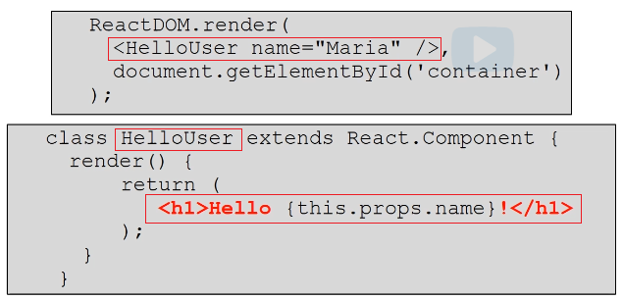

2.State

- attribute and values that represent current state of the component

- can be modified during component lifecycle

- should be initialized in the constructor

- access state by this.state

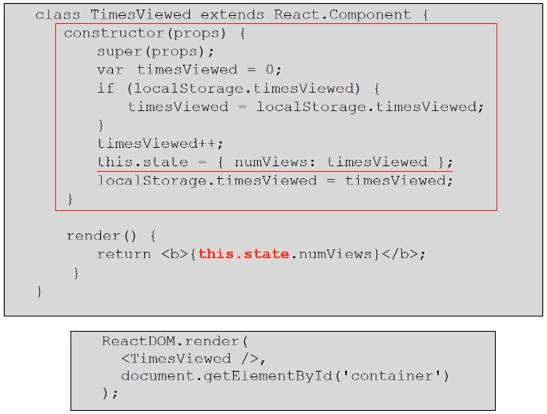

both can be used while rendering the component

properties -initialize

state -change during

Component Lifecycle

- React VirtualDOM invokes callback functions on component during lifecycle

- 3 stages

1. creating/mounting

2.updating

3. destroying / unmounting

-at each point react invoke optional functions can be written to control the component

Call Back functions

I. Mounting

- Component is created or added to VirtualDOM

1. constructor: creates component, initializes states based on properties

2. componentWillMount: invoked before component is added to VirtualDOM

3. componentDidMount: involved after component has been added to VirtualDOM and has been rendered

II. Updating:

- Called components prop or state is changing and component is re-rendered

1. componentWillReceiveProps: invoked before receiving new props. Eg: when its parent components are re-rendered

2. shouldComponentUpdate: Can be used to determine whether to re-render

3. componentWillUpdate: invoked before re-rendering after changing the state

4. componentDidUpdate: invoked after being re-rendered.

III. Unmounting:

- called when a component is being removed from the virtualDOM

1. componentWillUnmount: Invoked before component is removed from VirtualDOM and destroyed

3.3 React Events

- State of event change on user response

**- bind -** event to callback function

- change state - setState function

- setState calls render()

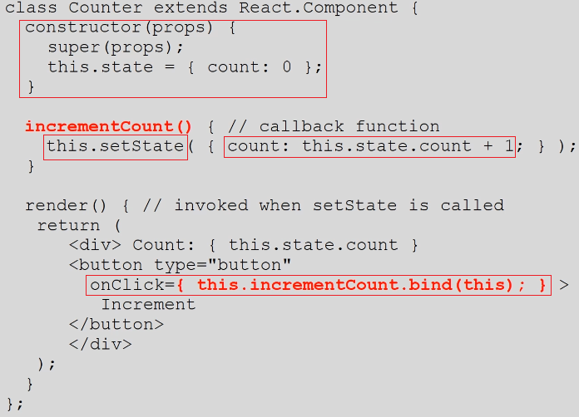

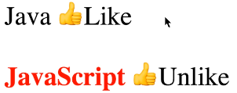

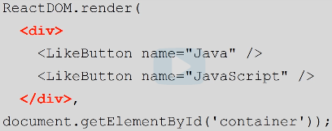

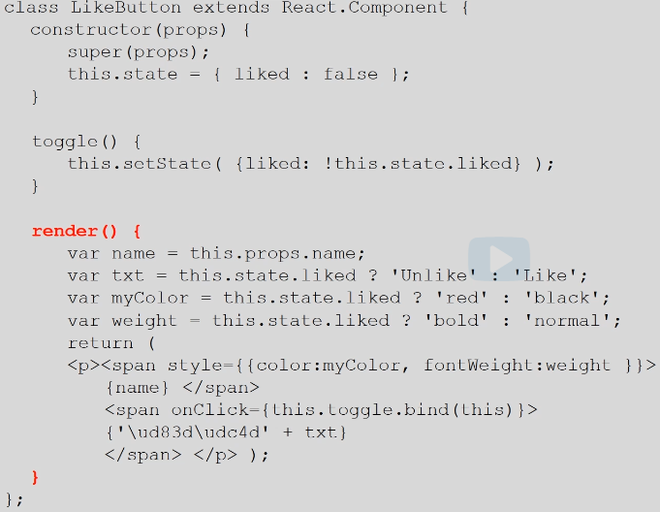

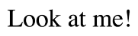

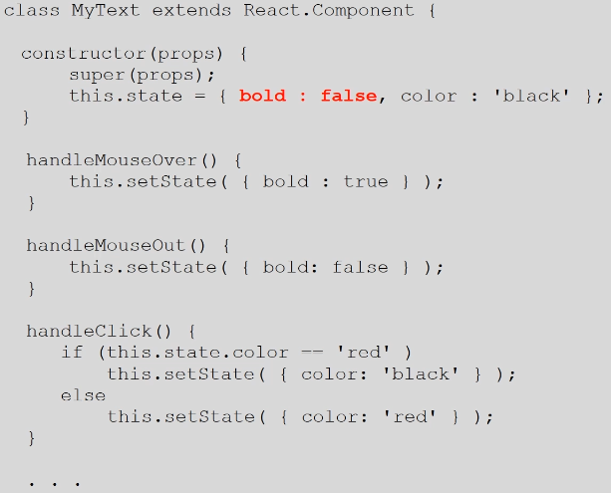

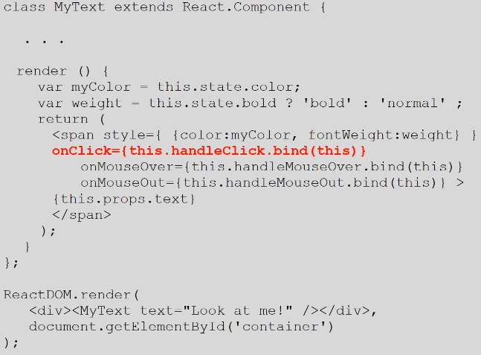

3.4 React Component Interactions

3.6 Using APIs with React

break code into components -work independently

interaction components in standard manner - less coupling

change 1 component without changing other - stability

SOA -service Oriented Architecture

- expose data and functionality through- service interfaces

- interfaces communication

SAAS

-service oriented architecture

- software runs as a service

- add feature/database is easy

Microservices

- Each instance for one service.

- Aggregate as required

REST

- collections of resources(not pages-content)

-REpresentational State Transfer

API - application Program Interface

set of URL- gives us data which we can use in application

Ex- content of NewYork times include in our website

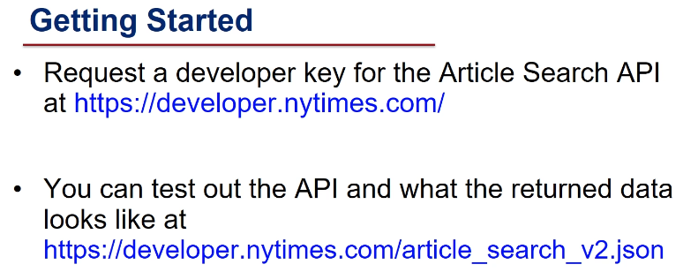

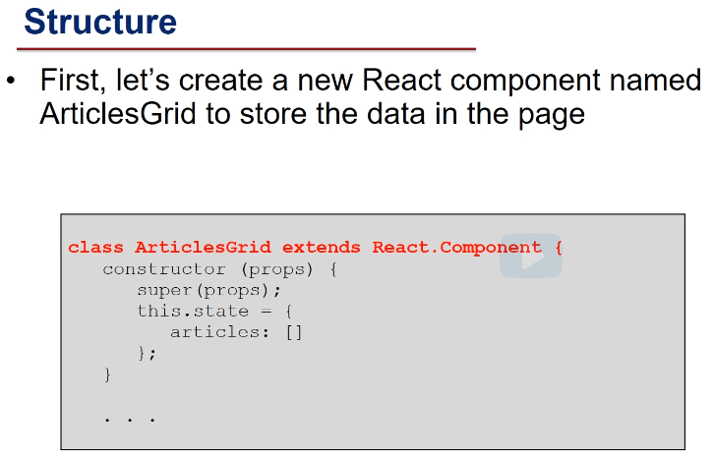

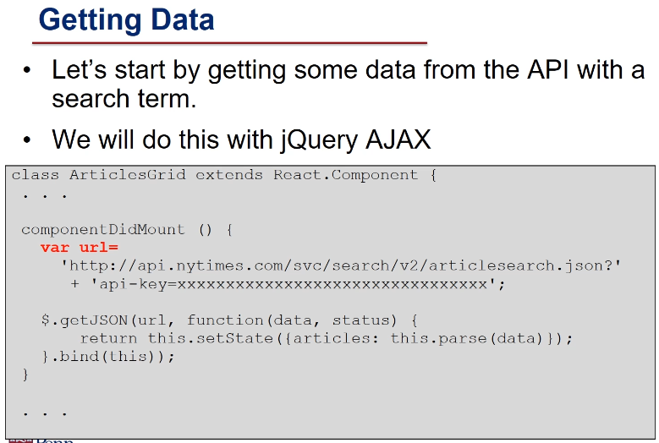

Note that you will need to get an API key at <https://developer.nytimes.com/>and set the API_KEY variable in the component Did Mount function in order for the code to work.

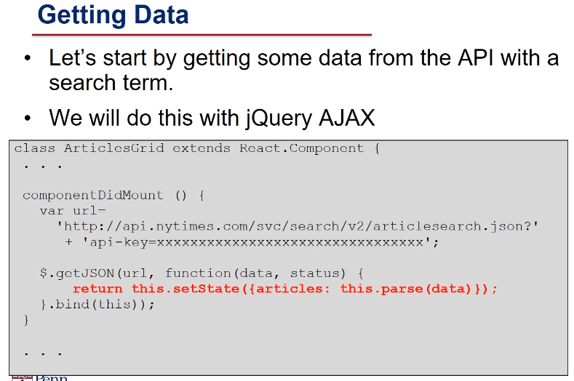

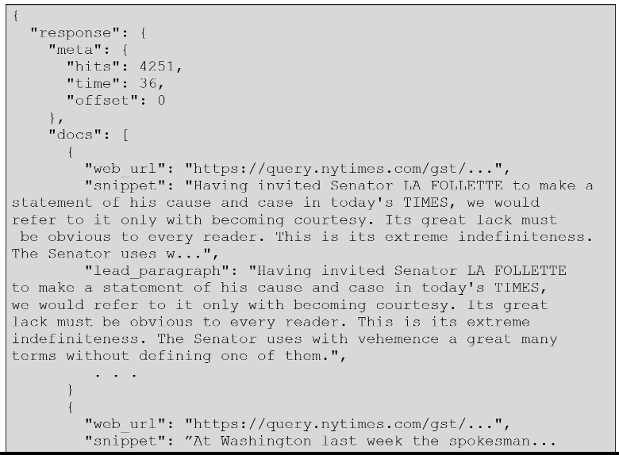

Parsing Data

-fetch small part of raw data

-URL of image, title of head line, url to news article

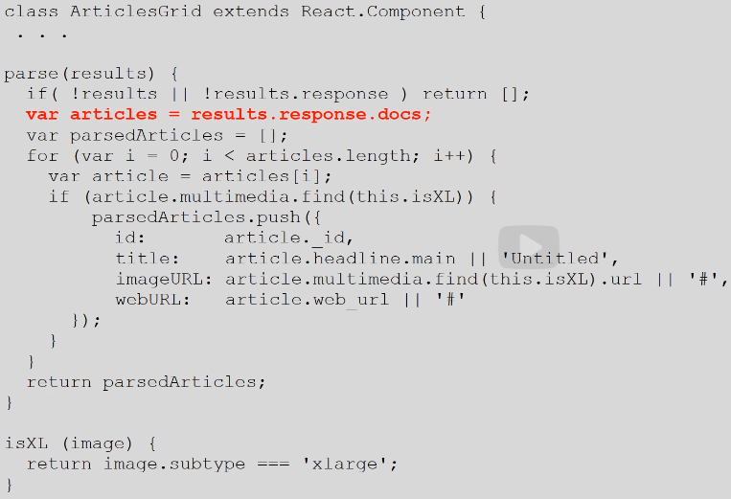

Display Data

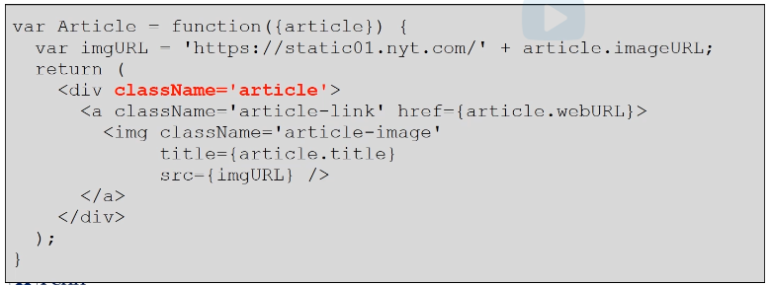

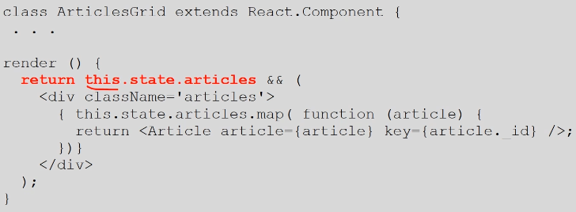

**3.7 React Application Development**

- Separate components in different files than html

Node.js

- platform user to prepare js application to deploy.

- node package manager and manage dependencies

- instead of script separate code as modular.

var React = require('react');

var ReactDOM = require('react-dom');

import MyComponent from './MyComponent.js'

require : need library

import: importing code form other file to this file

https://nodejs.org/en/download/

install Node.js

node package manager -: npm

npm install npm -g

easy to include dependencies

transform jsx to JS

module and bundle code together

Babel : for JSX and ES6 transformation

Webpack: for bundling component to single application

npm install -g create-react-app

to create React App

create-react-app my-app

Anatomy of React

1. package.json : configuration file includes all informtaion about app, dependencies, shortcut for script

2. public: directory containing html files, images other static web content

3. src: directory containing JS and CSS

create react app package:

default app as follows:

- npm start

- start default web server that listens http request on port 3000

default web application on browser

- http://localhost:3000/

incorporate component

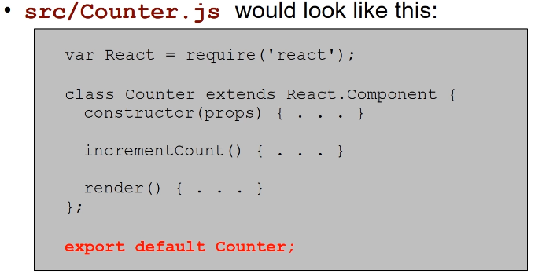

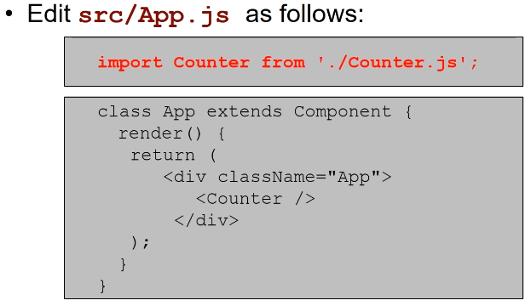

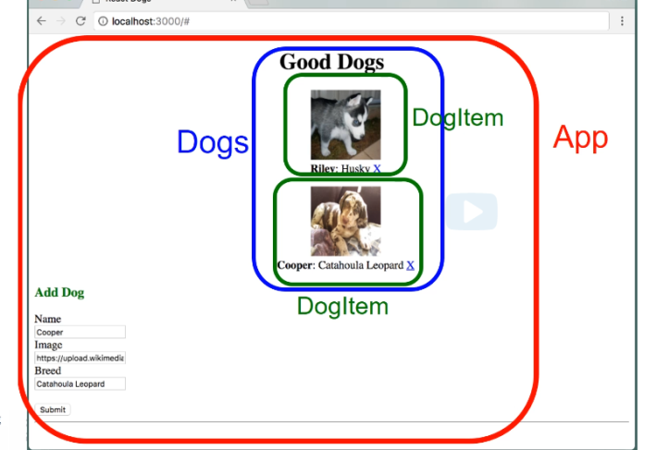

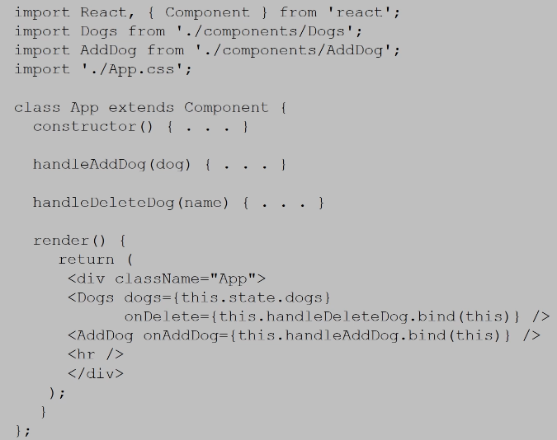

Testing React Apps

Mocha : test framework for any js code

Chai : assertion library for behavior Driven Testing

Enzyme: testing utility for manipulating and inserting React component

include enzyme and chai

npm install --save-dev enzyme react-test-rendered chai

src directory: js, css, test directory

test directory : test code '.test.js' extension.

Getting started

- create default App.test.js or can write own

- include necessary lib

import React from 'react';

import ReactDOM from 'react-dom';

- import keyword from Enzyme

import (mount, shallow) from 'enzyme';

- import keywords from Chai

import (except) from 'chai';

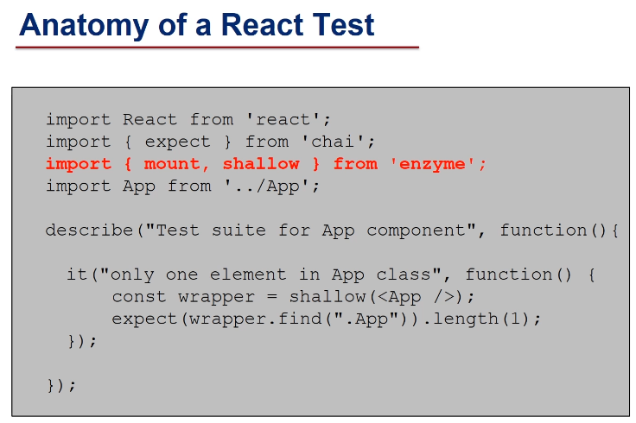

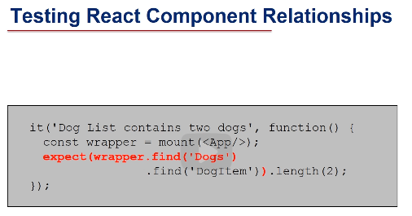

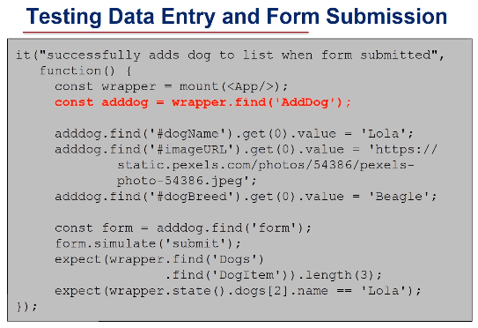

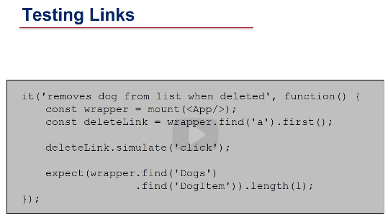

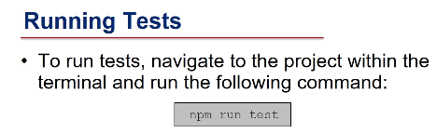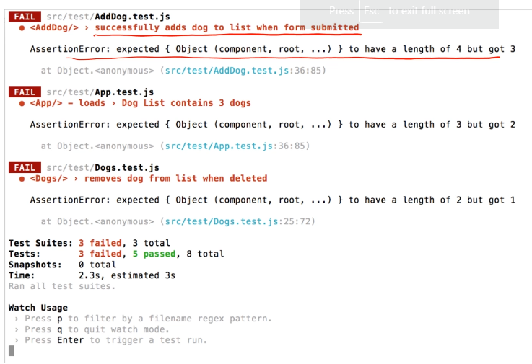

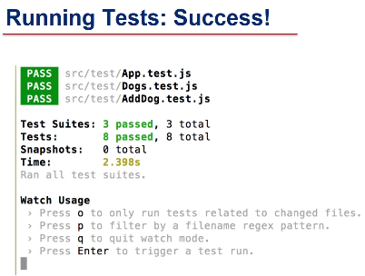

**3.8 Introduction to ES6**

ECMA script 6 - 2015

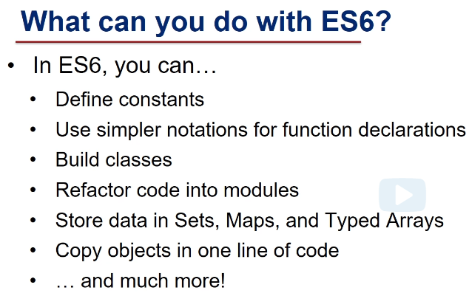

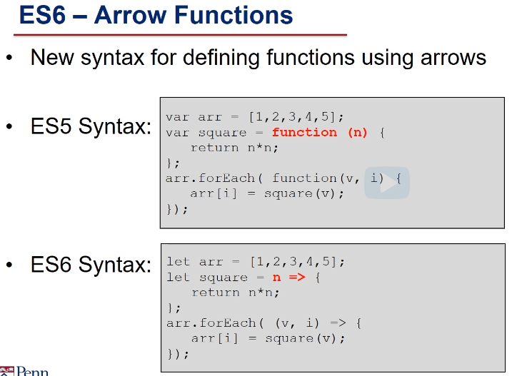

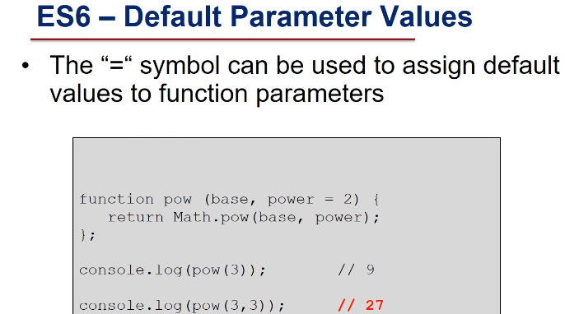

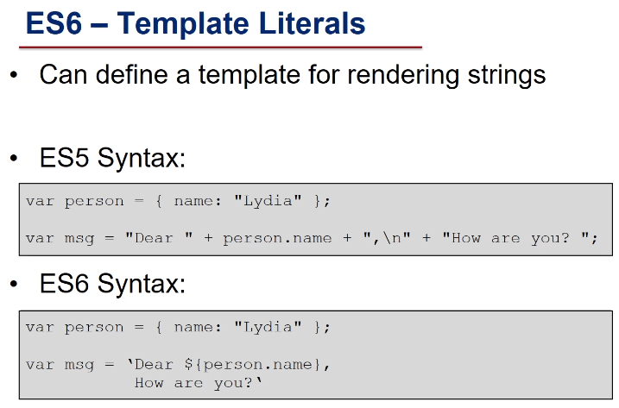

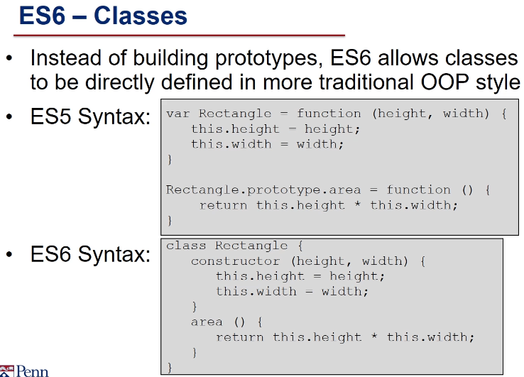

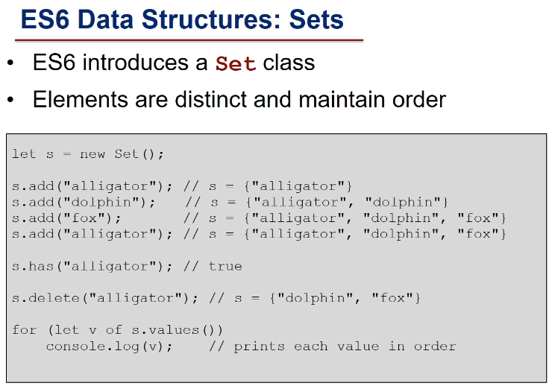

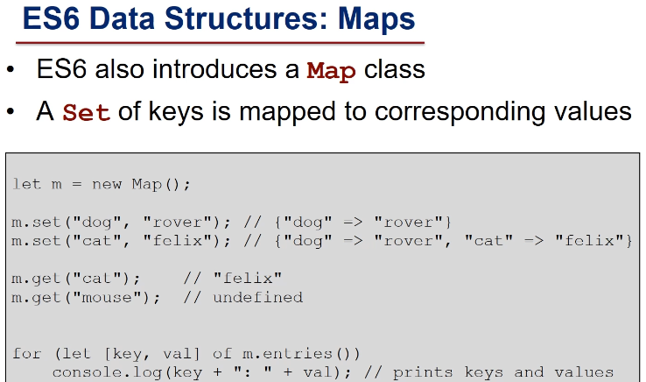

There is a good explanation of the difference between "let" and "var" at <http://www.jstips.co/en/javascript/keyword-var-vs-let/>

**3.9 Introduction to D3.js**

generate text -react, js

generate graphics-images -SVG

- do not lose quality

- part of dom

- modified by js

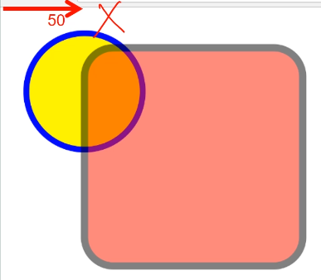

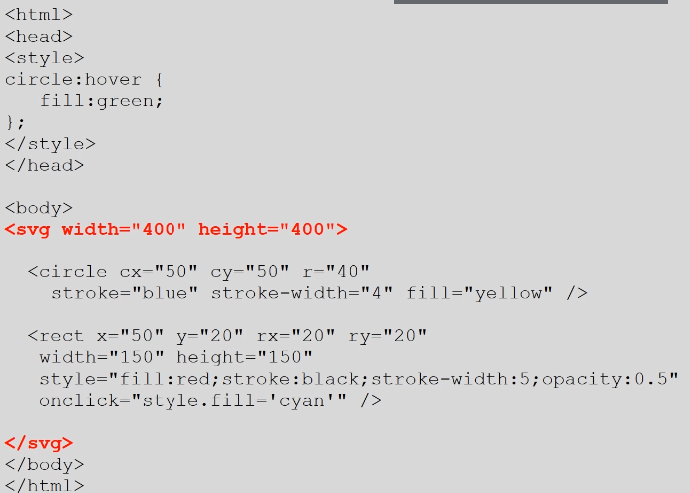

D3.js

-data driven document

-dynamically generate graphics

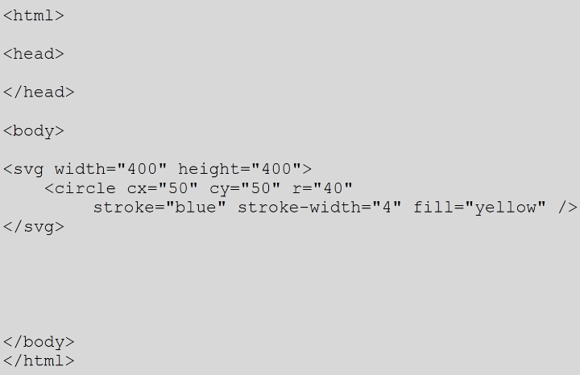

using D3

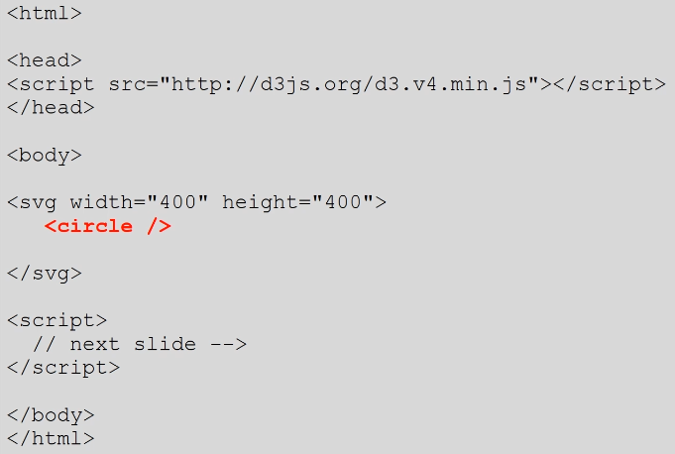

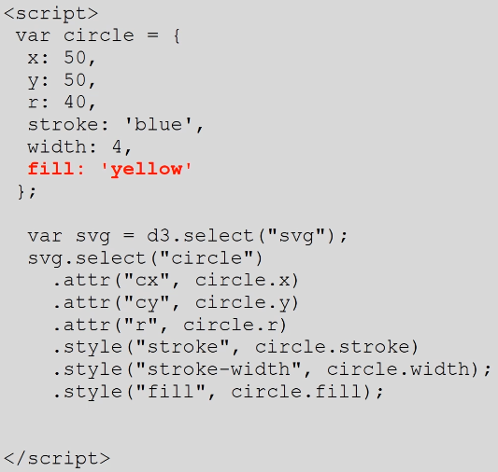

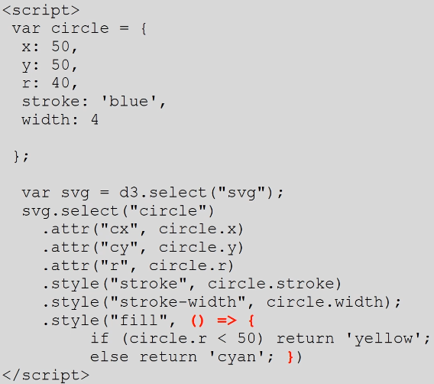

**3.10 Creating charts with D3**

D3 with data -> chart

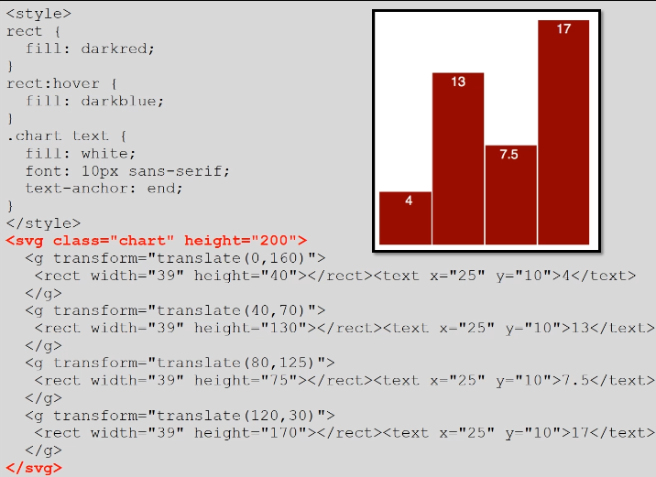

dynamic calculation

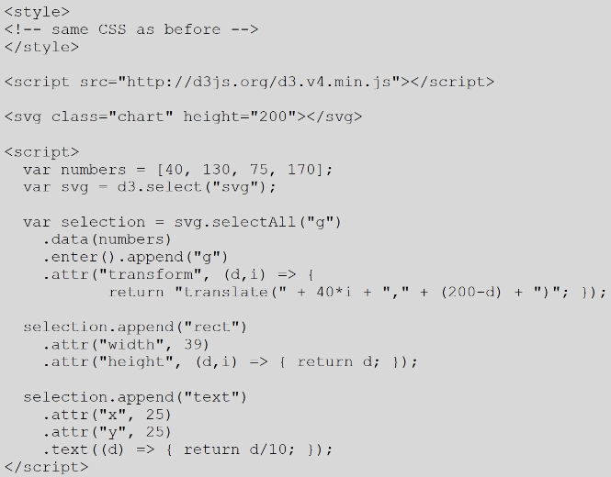

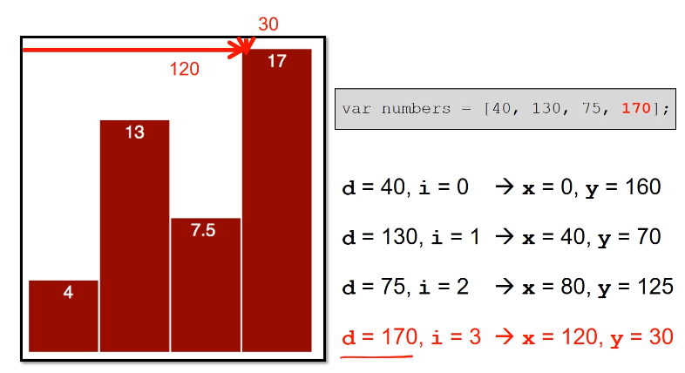

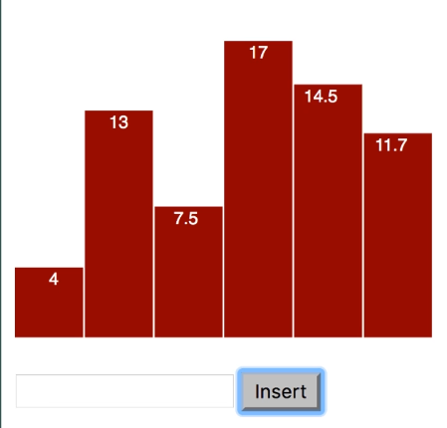

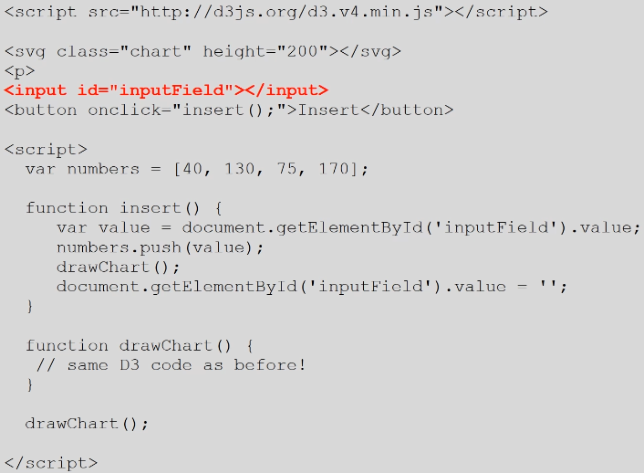

**3.11Using data with D3**

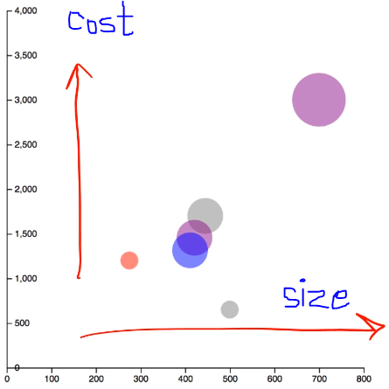

Data used in D3 is object not just number

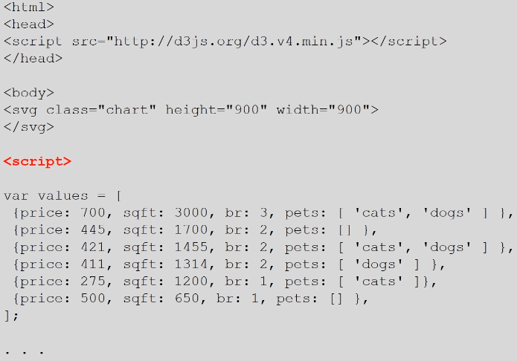

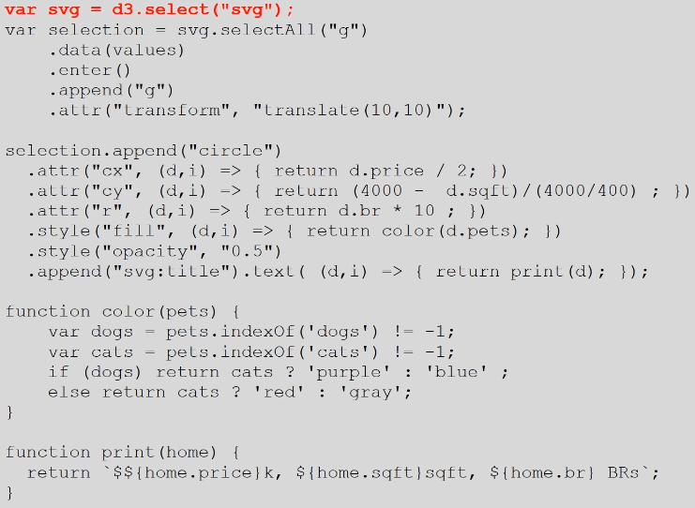

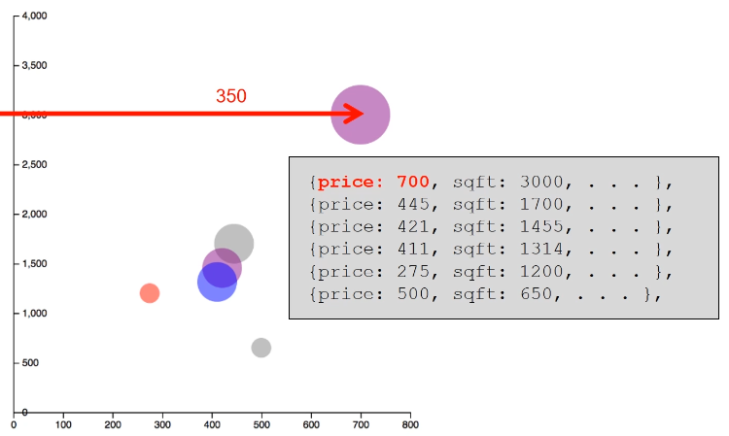

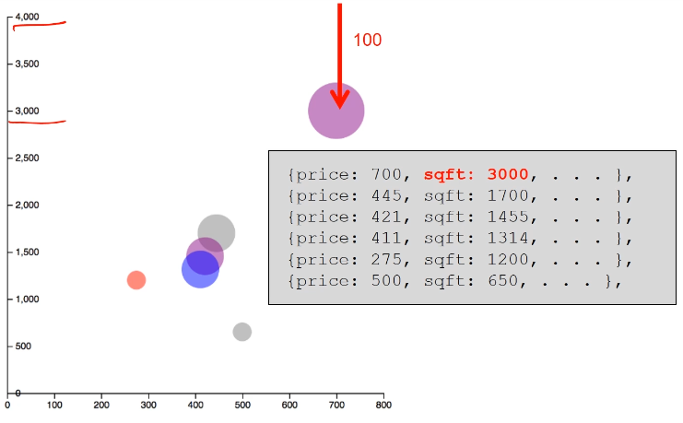

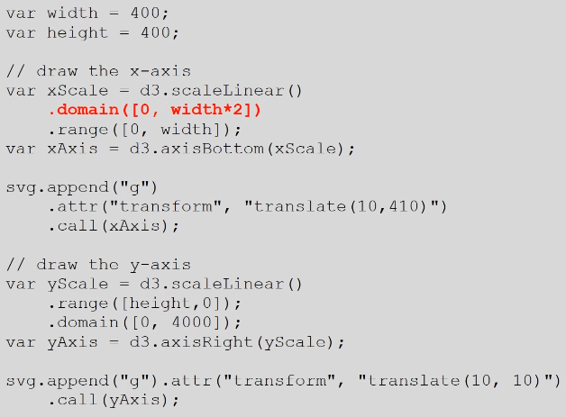

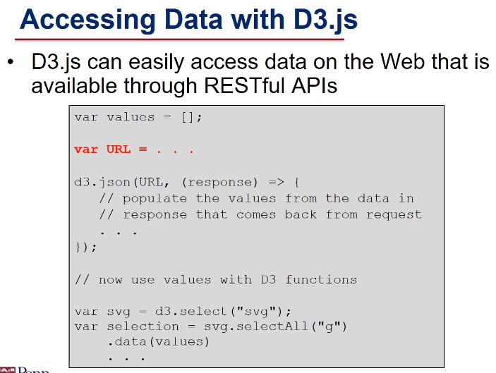

[Node.js](https://courses.edx.org/courses/course-v1:PennX+SD4x+3T2019/course/#block-v1:PennX+SD4x+3T2019+type@sequential+block@56557737fe544079b6b43aaa9dc817bb)

**4.1 Introduction to Node.js**

JS on server

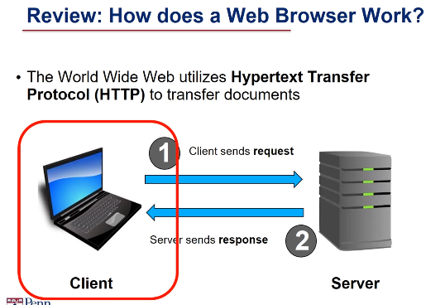

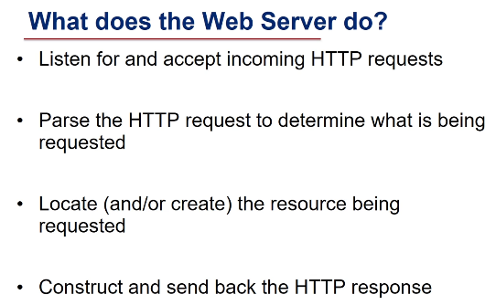

* Developing a web server from scratch is rather difficult.
* No matter which programming language you are using, you have to worry about things
* like network communication, doing things simultaneously, error handling, et cetera.
* In this course, we're not going to do that, but rather,
* we'll build our web applications on top of a JavaScript framework called Node.

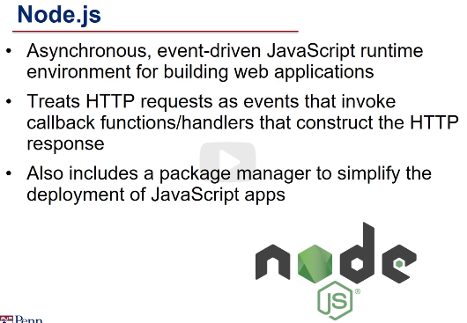

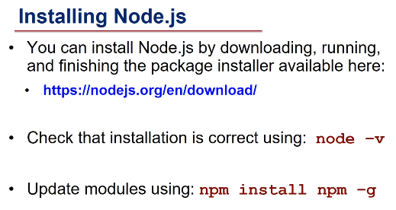

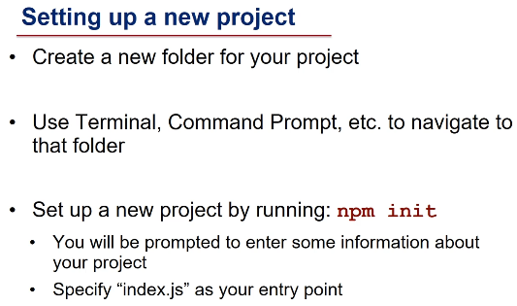

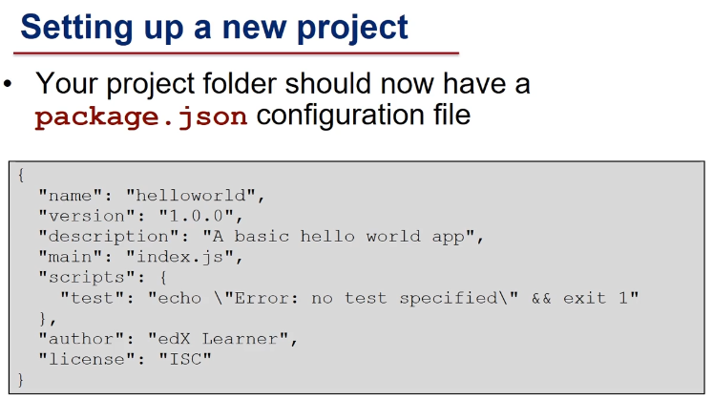

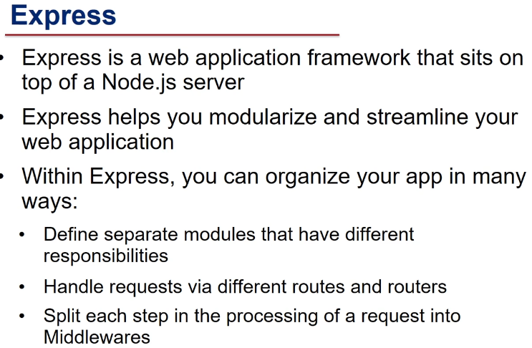

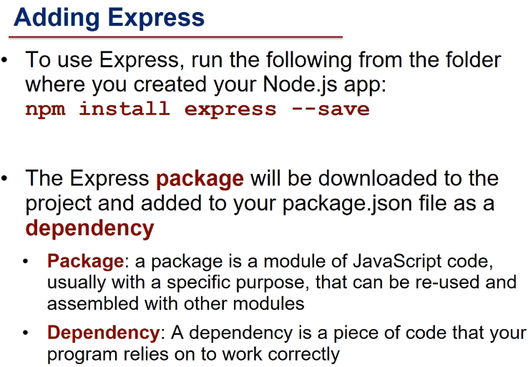

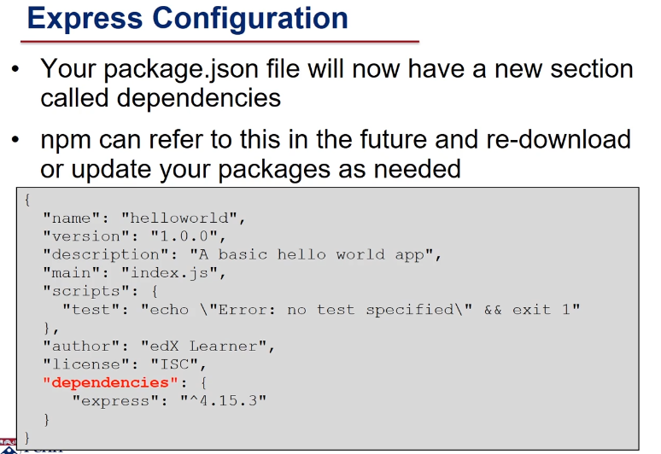

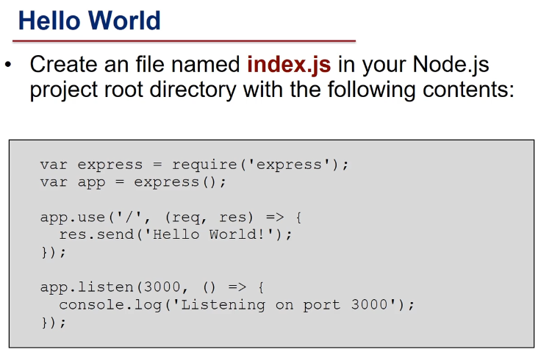

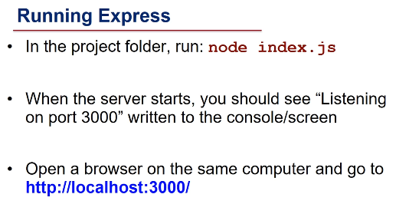

4.2 Node requests and responses

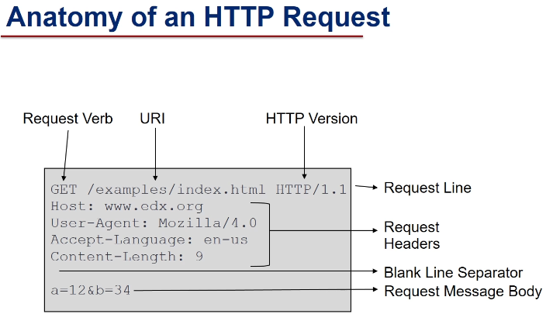

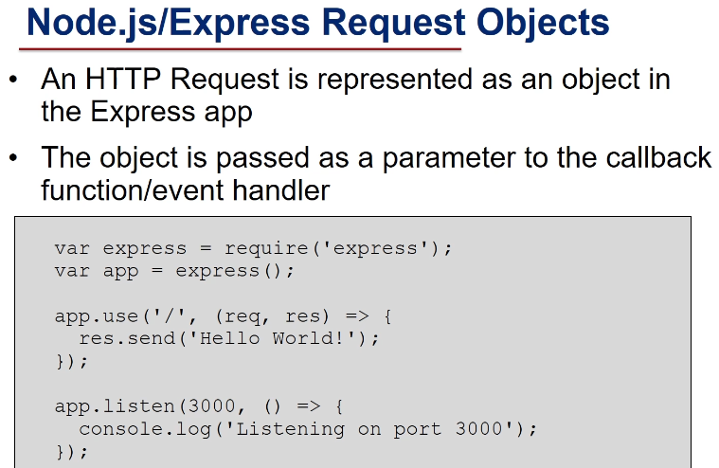

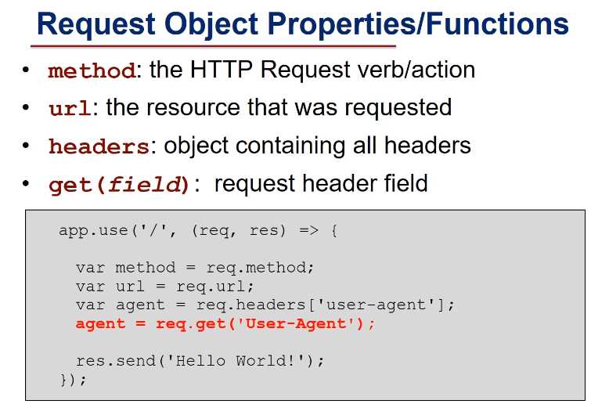

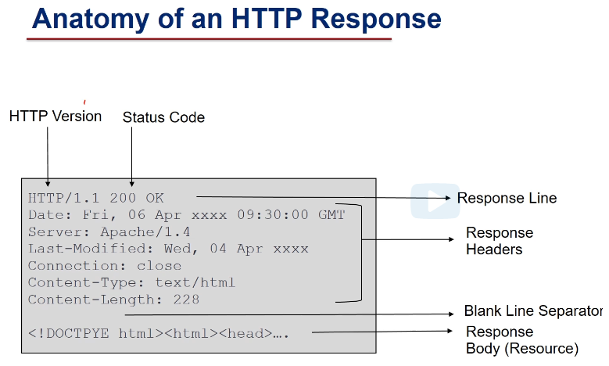

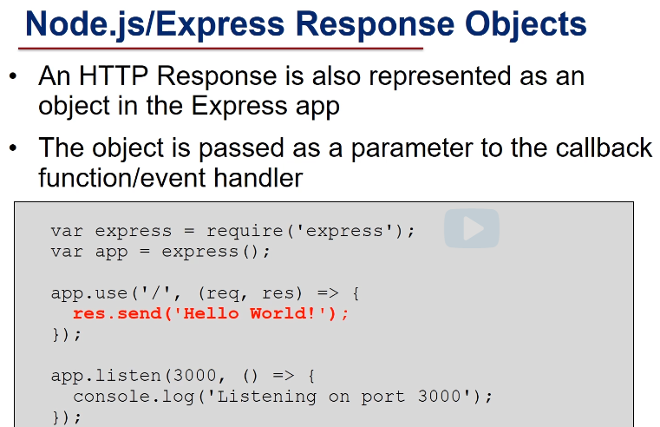

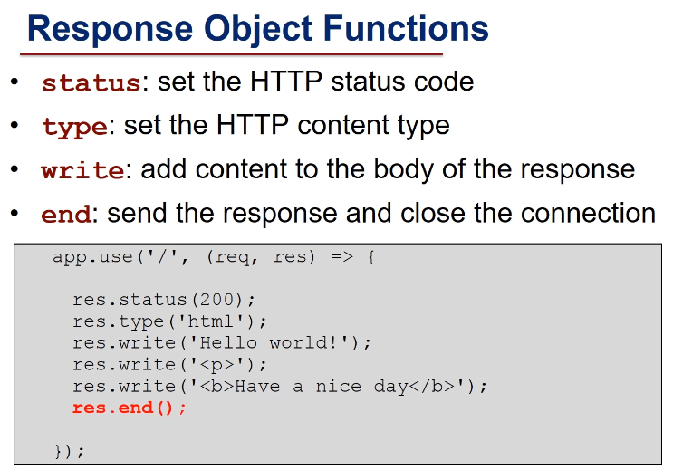

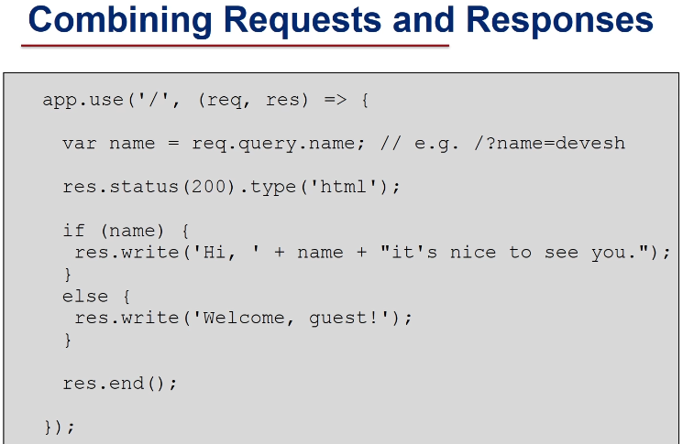

4.3 Node routing and middleware

Different Responses for different requests

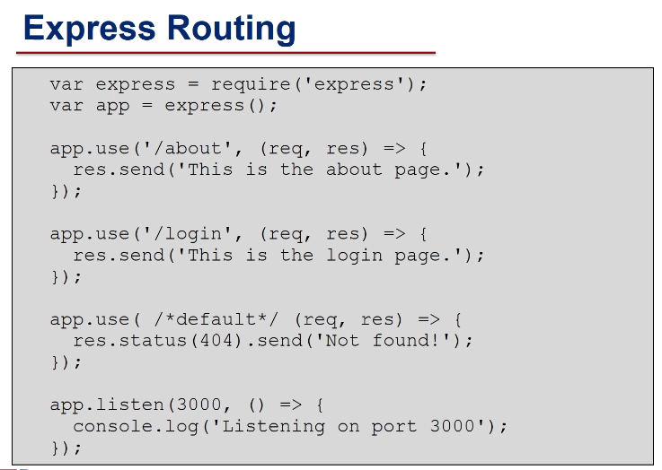

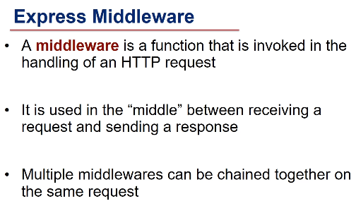

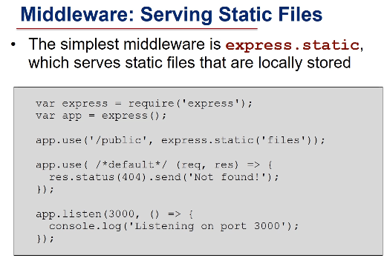

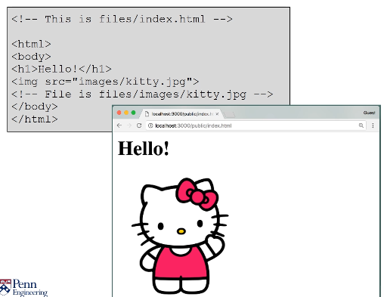

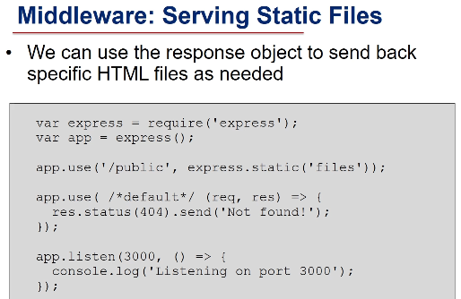

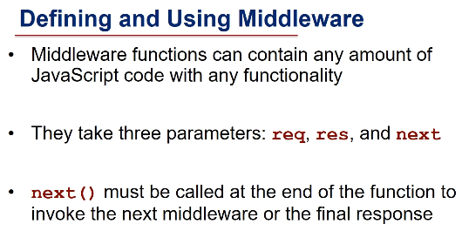

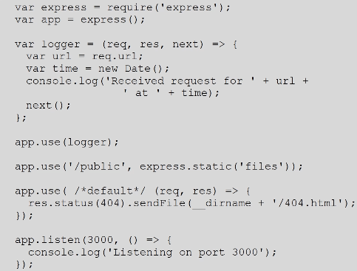

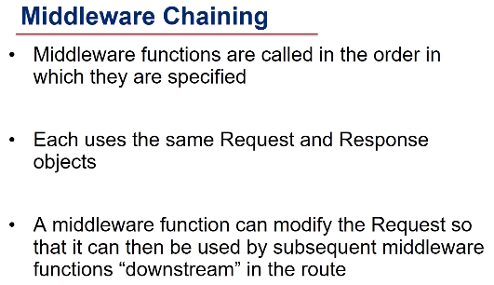

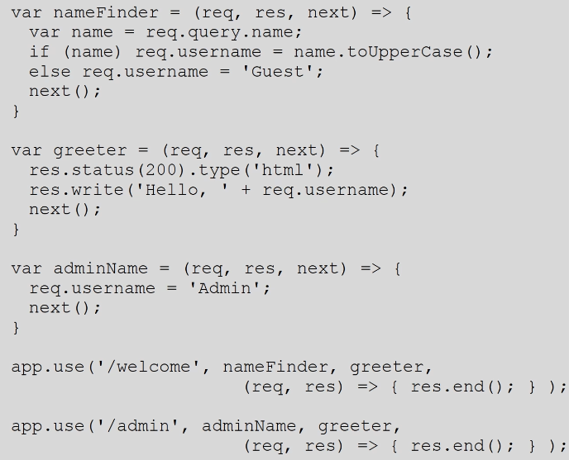

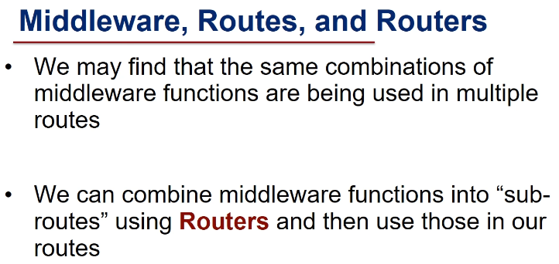

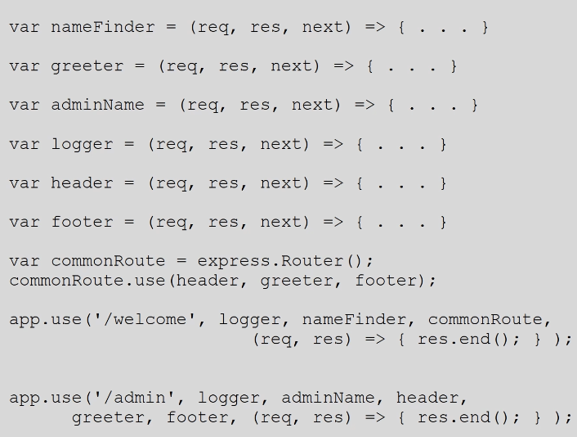

4.4 Sending user data to Node

get data from user

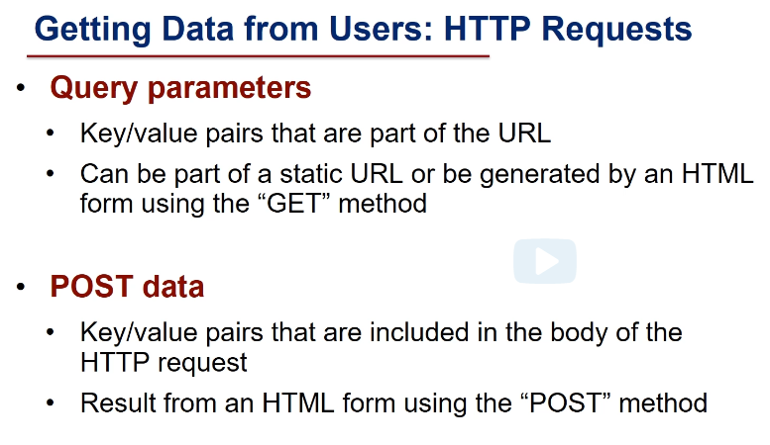

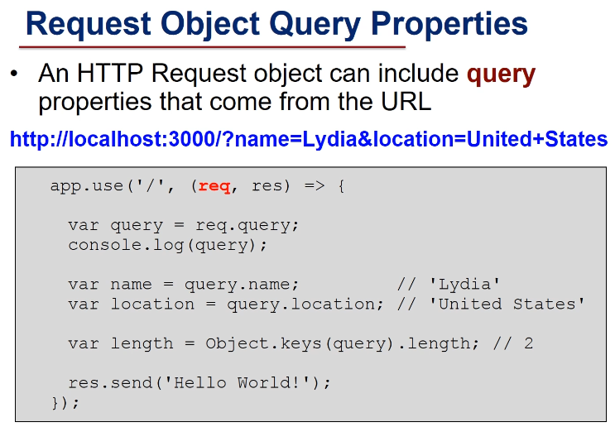

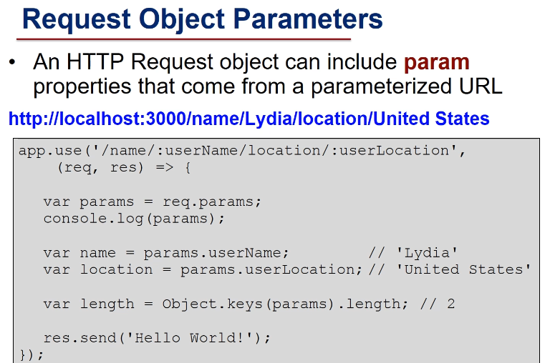

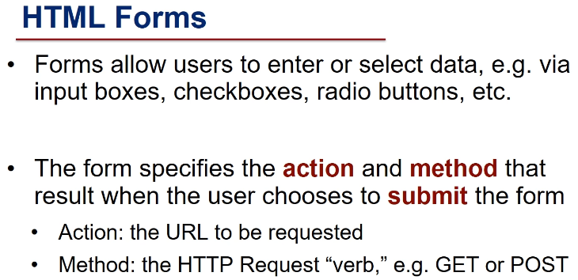

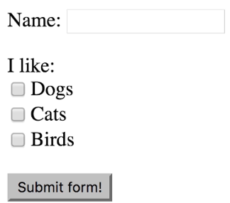

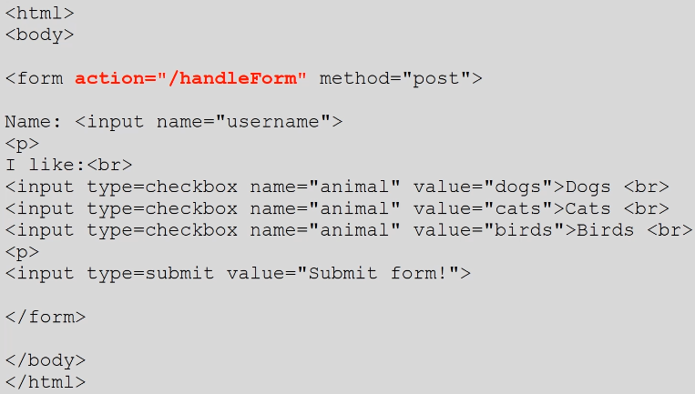

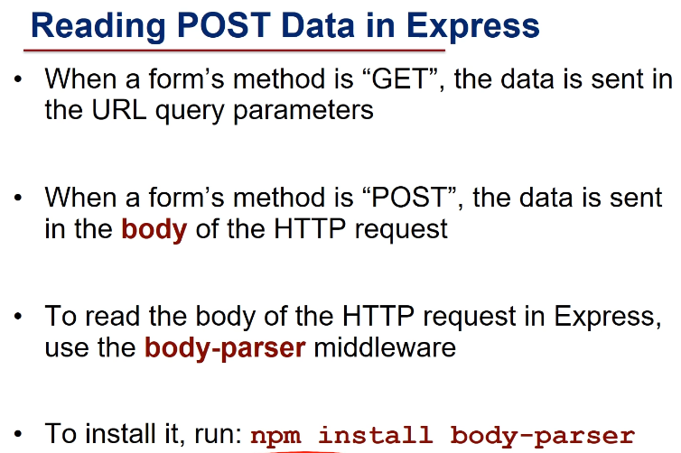

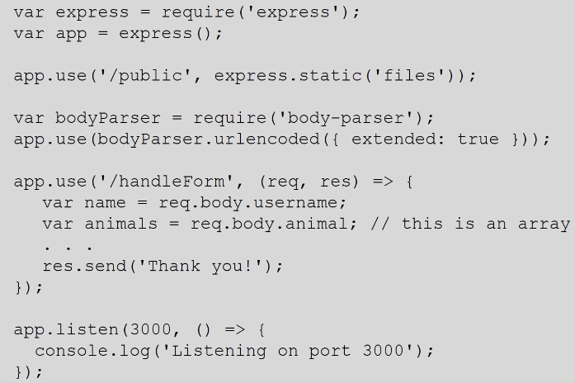

4.5 Using EJS with Node



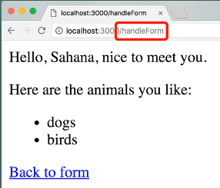

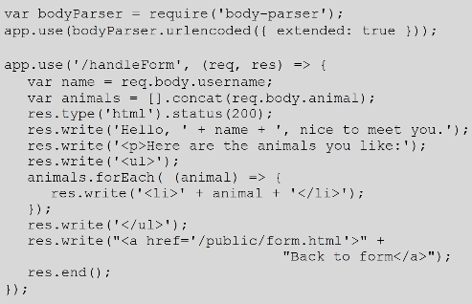

separate format from functionality. Use EJS

